Identification: we are given k and smallest/largest.

In smallest we make max heap. This is because all the greater elements come at the top and we simply remove them to get the kth smallest element.

In greatest we make min heap. This is because all the smaller elements come at the top and we simply remove them to get the kth largest element.

In sorting complexity is nlogn and in heaps is nlogk.

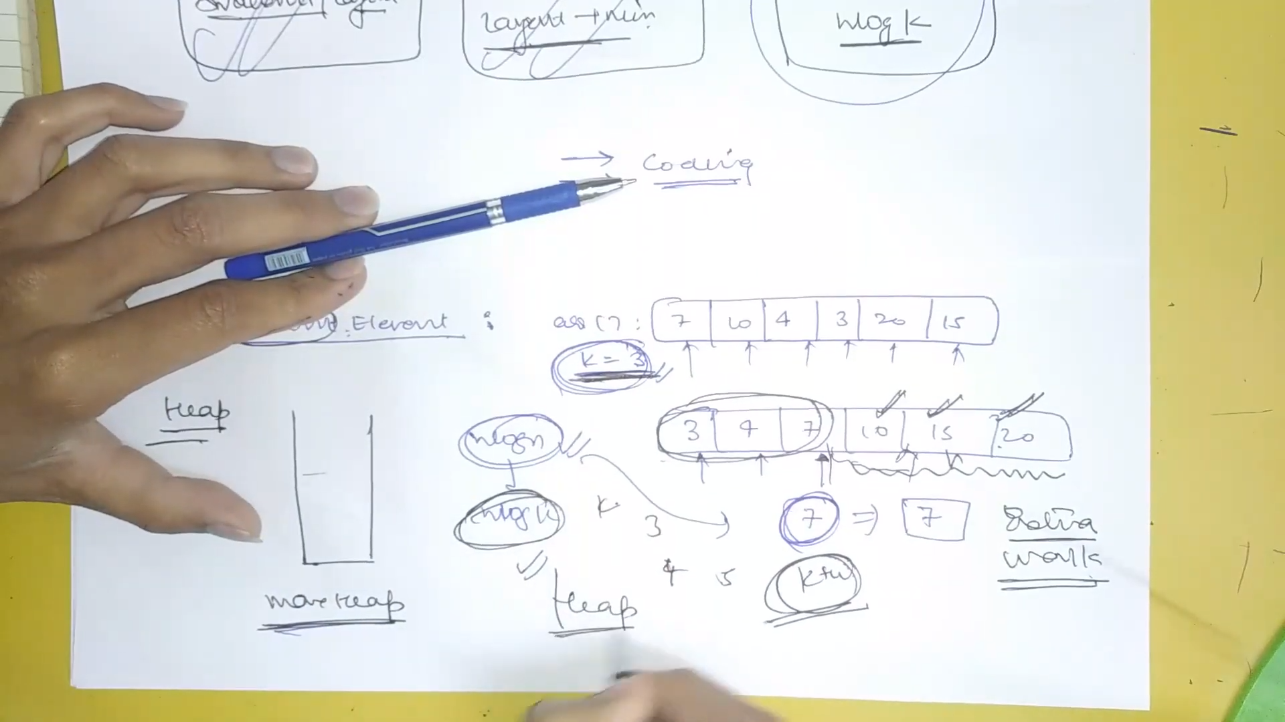

We are sorting the extra elements as well. So just sort the first kth elements since we only need to find it. Don’t do extra work.

For example for finding the 3rd smallest element we make a max heap and keep popping the 4th element from bottom (ie the top element) after sorting the 4 elements because it will never qualify for the answer.

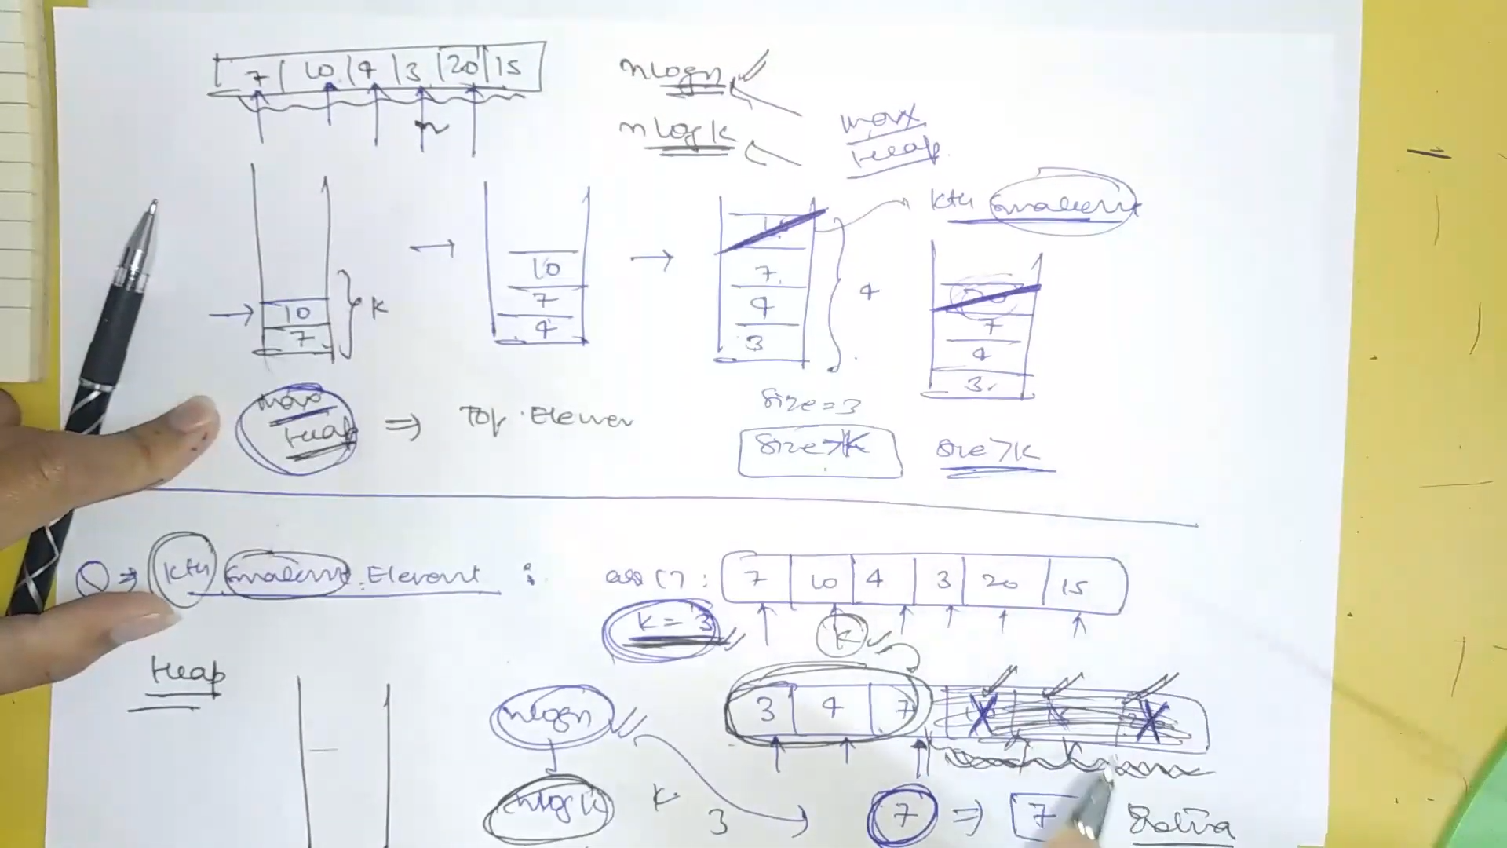

Syntax for min and max heap

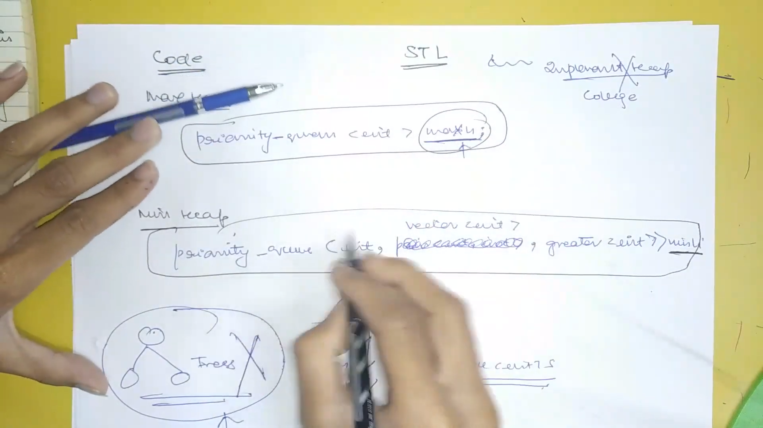

priority_queue <int, vector<int>, greater<int> > pq;

**If we want to make a pair then syntax**

priority_queue<pair<int, int> > pq; for max heap

typedef pair<int, int> pi;

priority_queue<pi, vector<pi>, greater<pi> > pq;

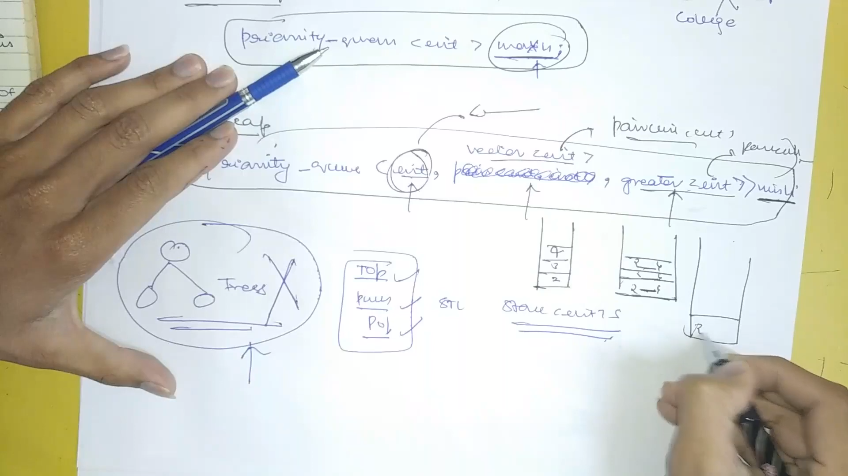

PPI for easy pair

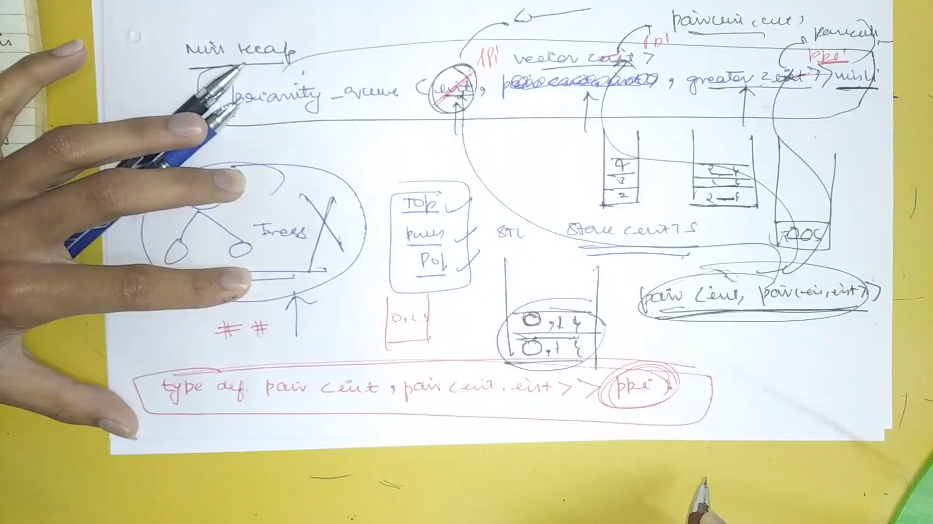

**Problem 2: Video 2: Kth smallest element**

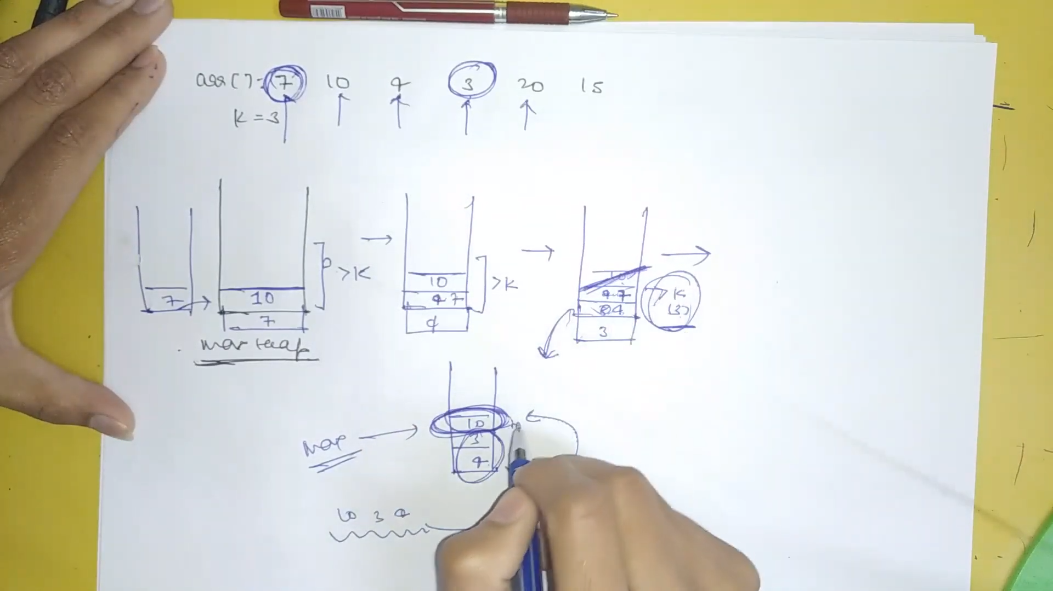

We make a max heap and as soon as size reaches greater than 3 we pop the element.

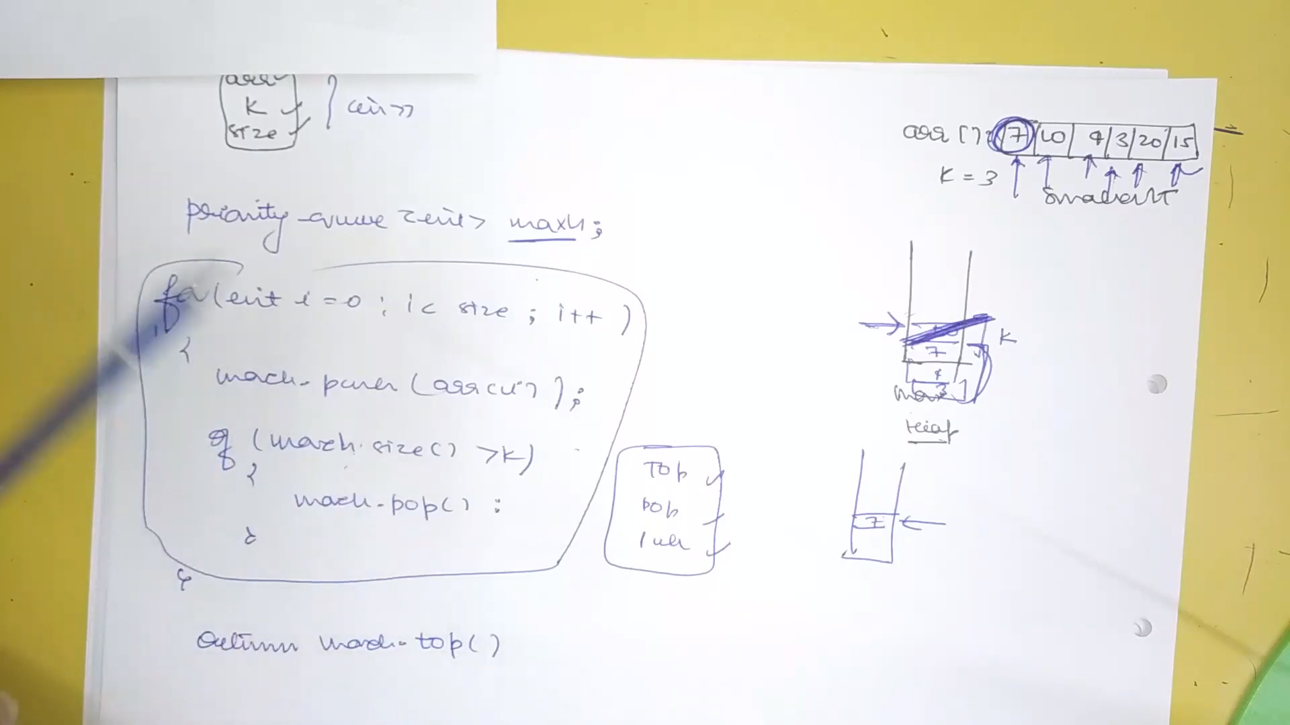

**Problem 3: Video 3:** Return K Largest Elements in Array

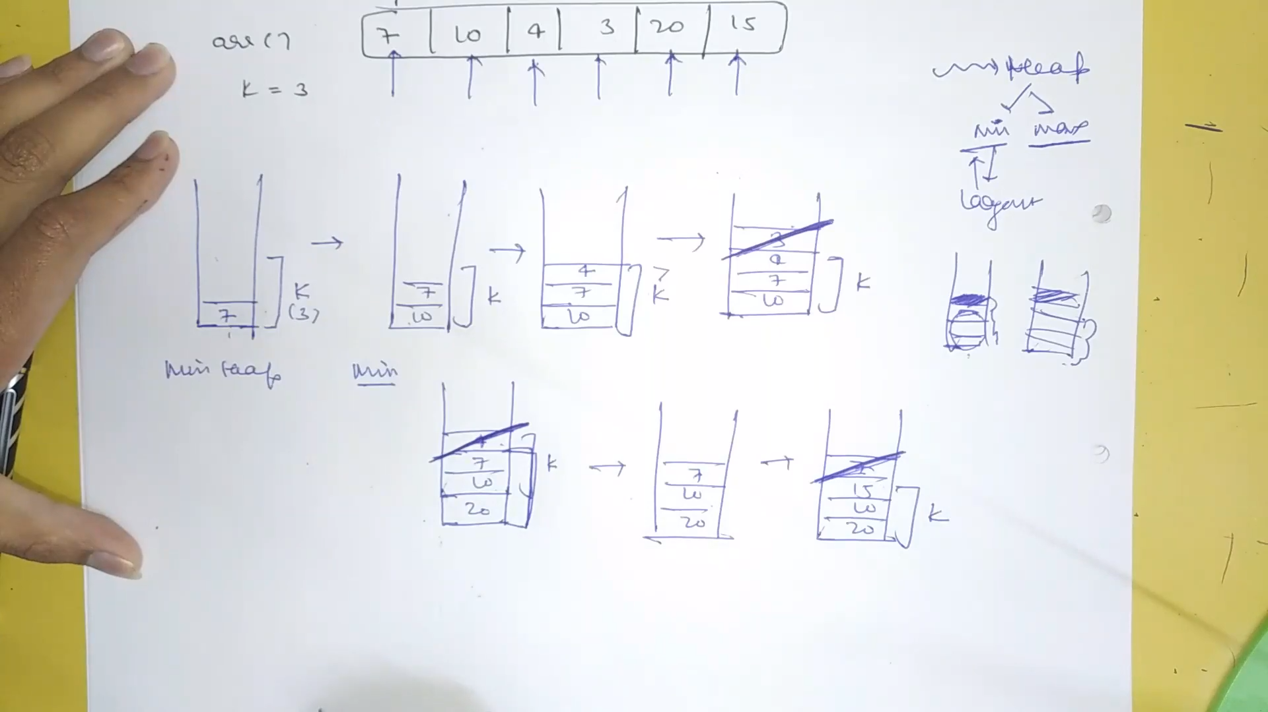

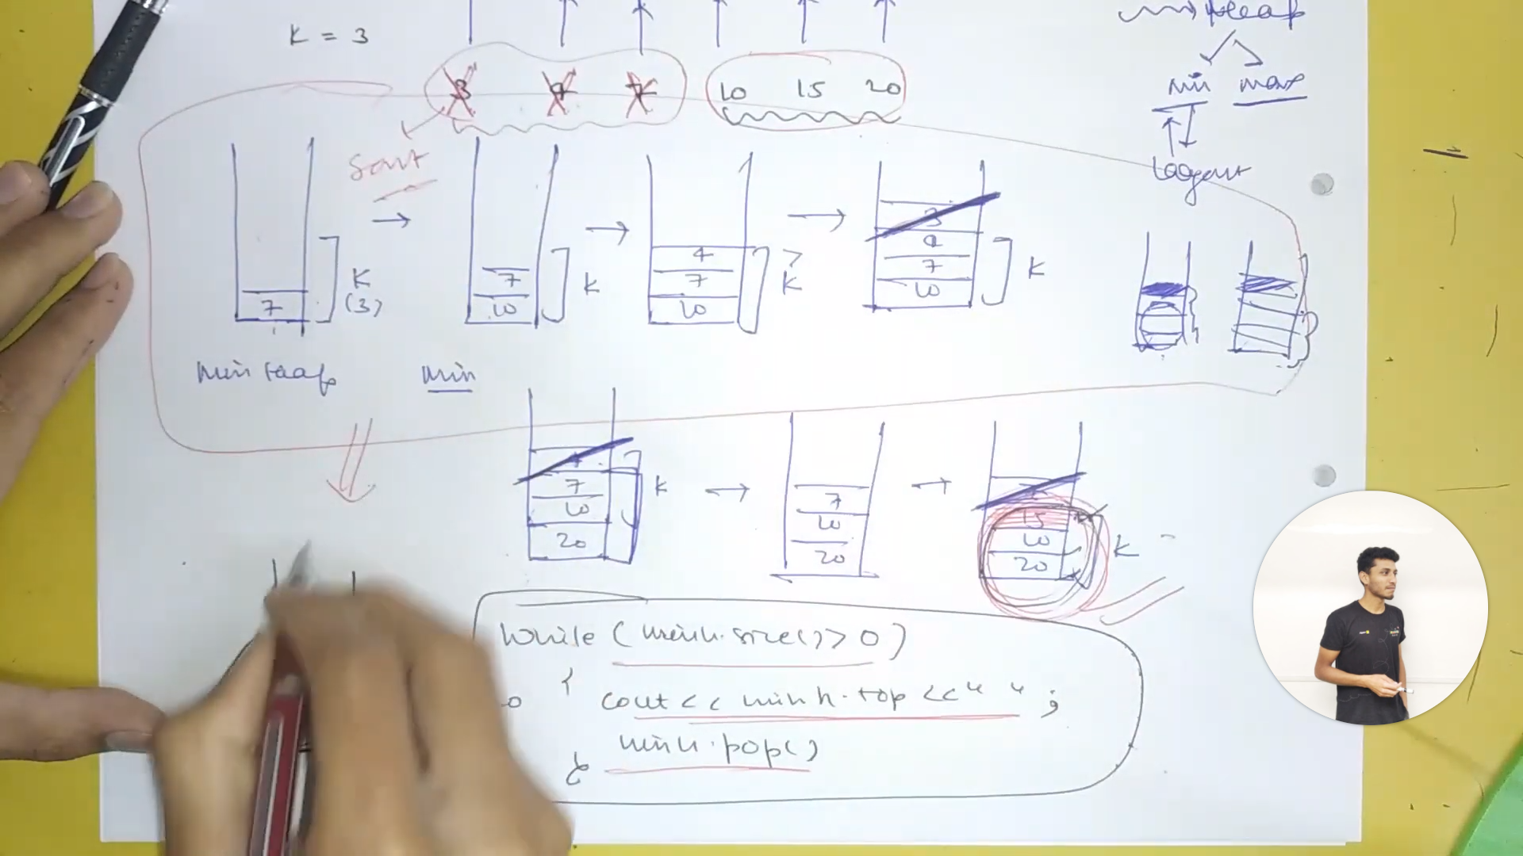

**Problem 4: Video 4:** Sort a K sorted array

The position at which the number should come is k times left or right to the number.

Earlier we used to sort all elements but now we sort k elements and return the topmost so order is nlogk.

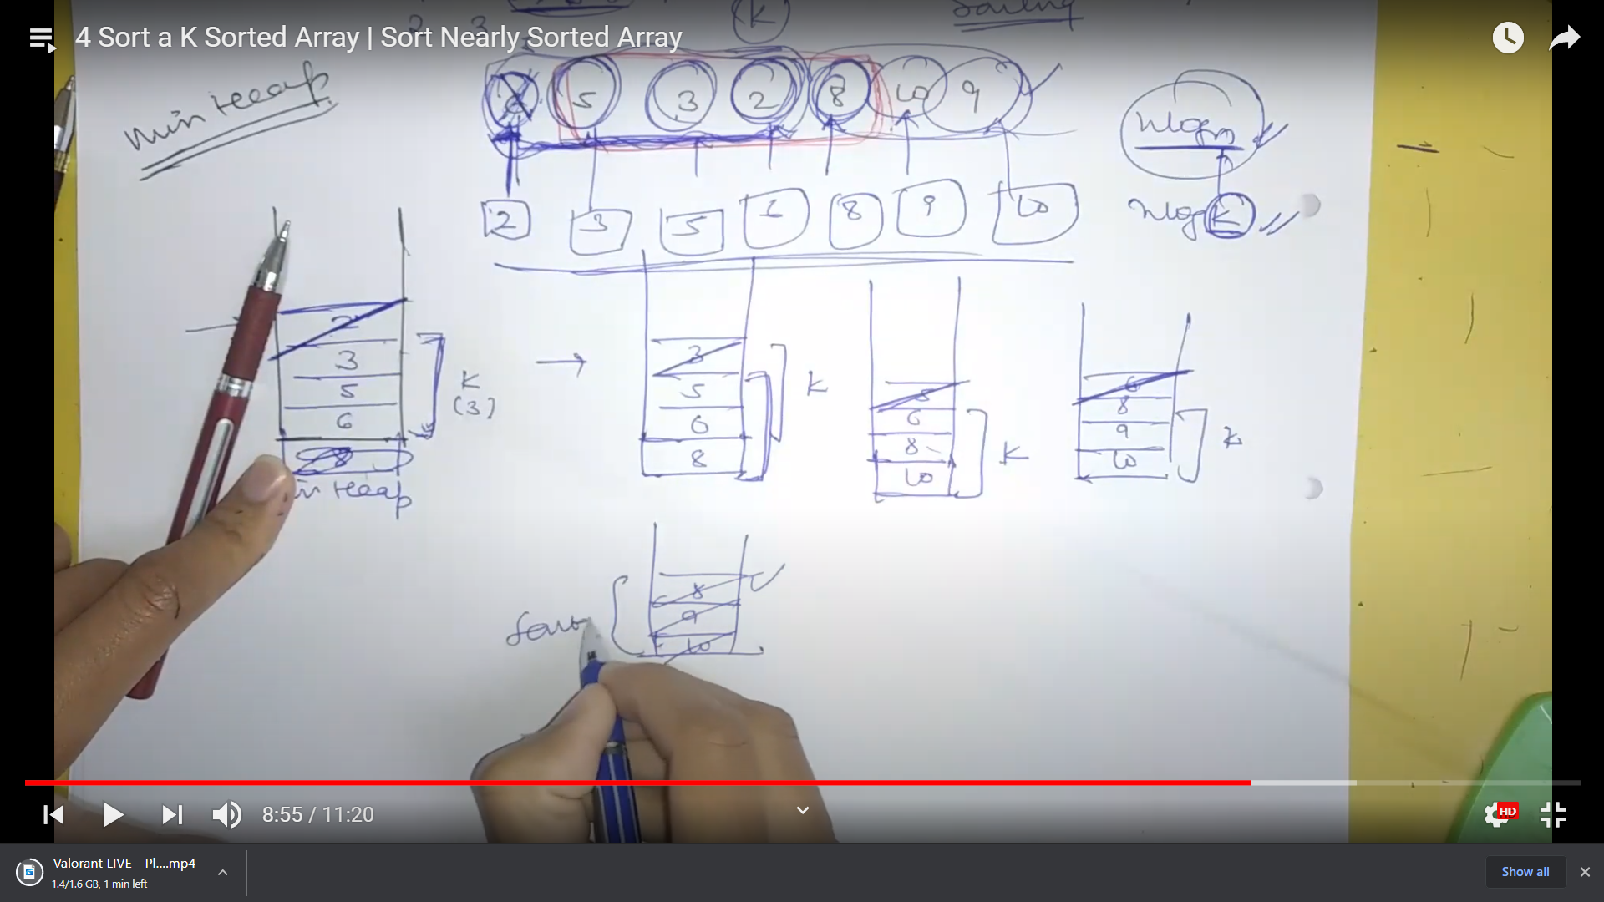

**Problem 5: Video 5:** K Closest Numbers

We are given a number and we have to subtract it from all the numbers in the array and then return those numbers which have the least difference.

We make a max heap with pair, 1)abs difference 2)the number and remove the topmost elements after k.

Last we return all the remaining elements.

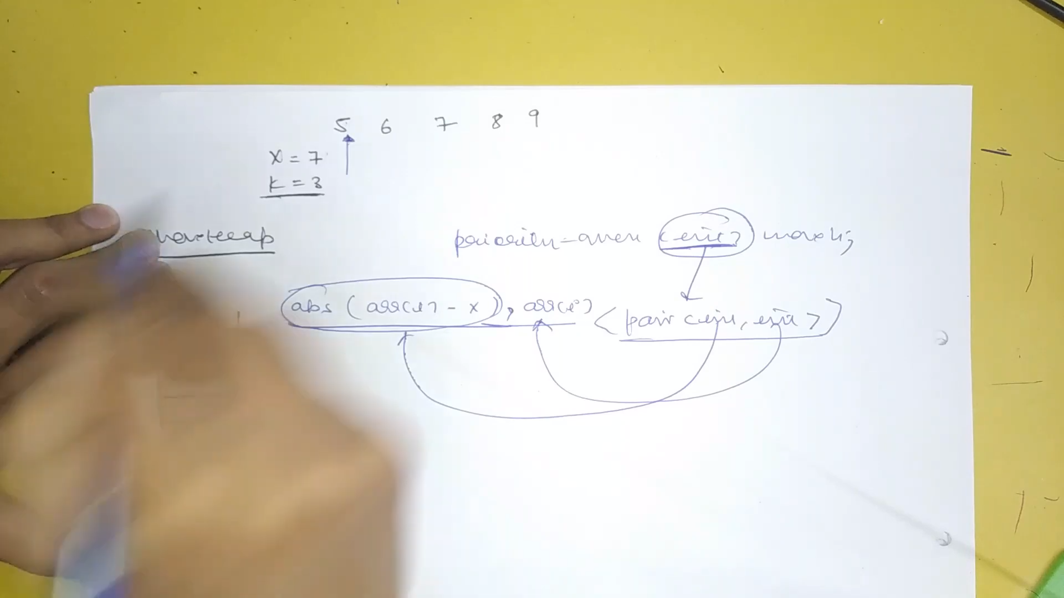

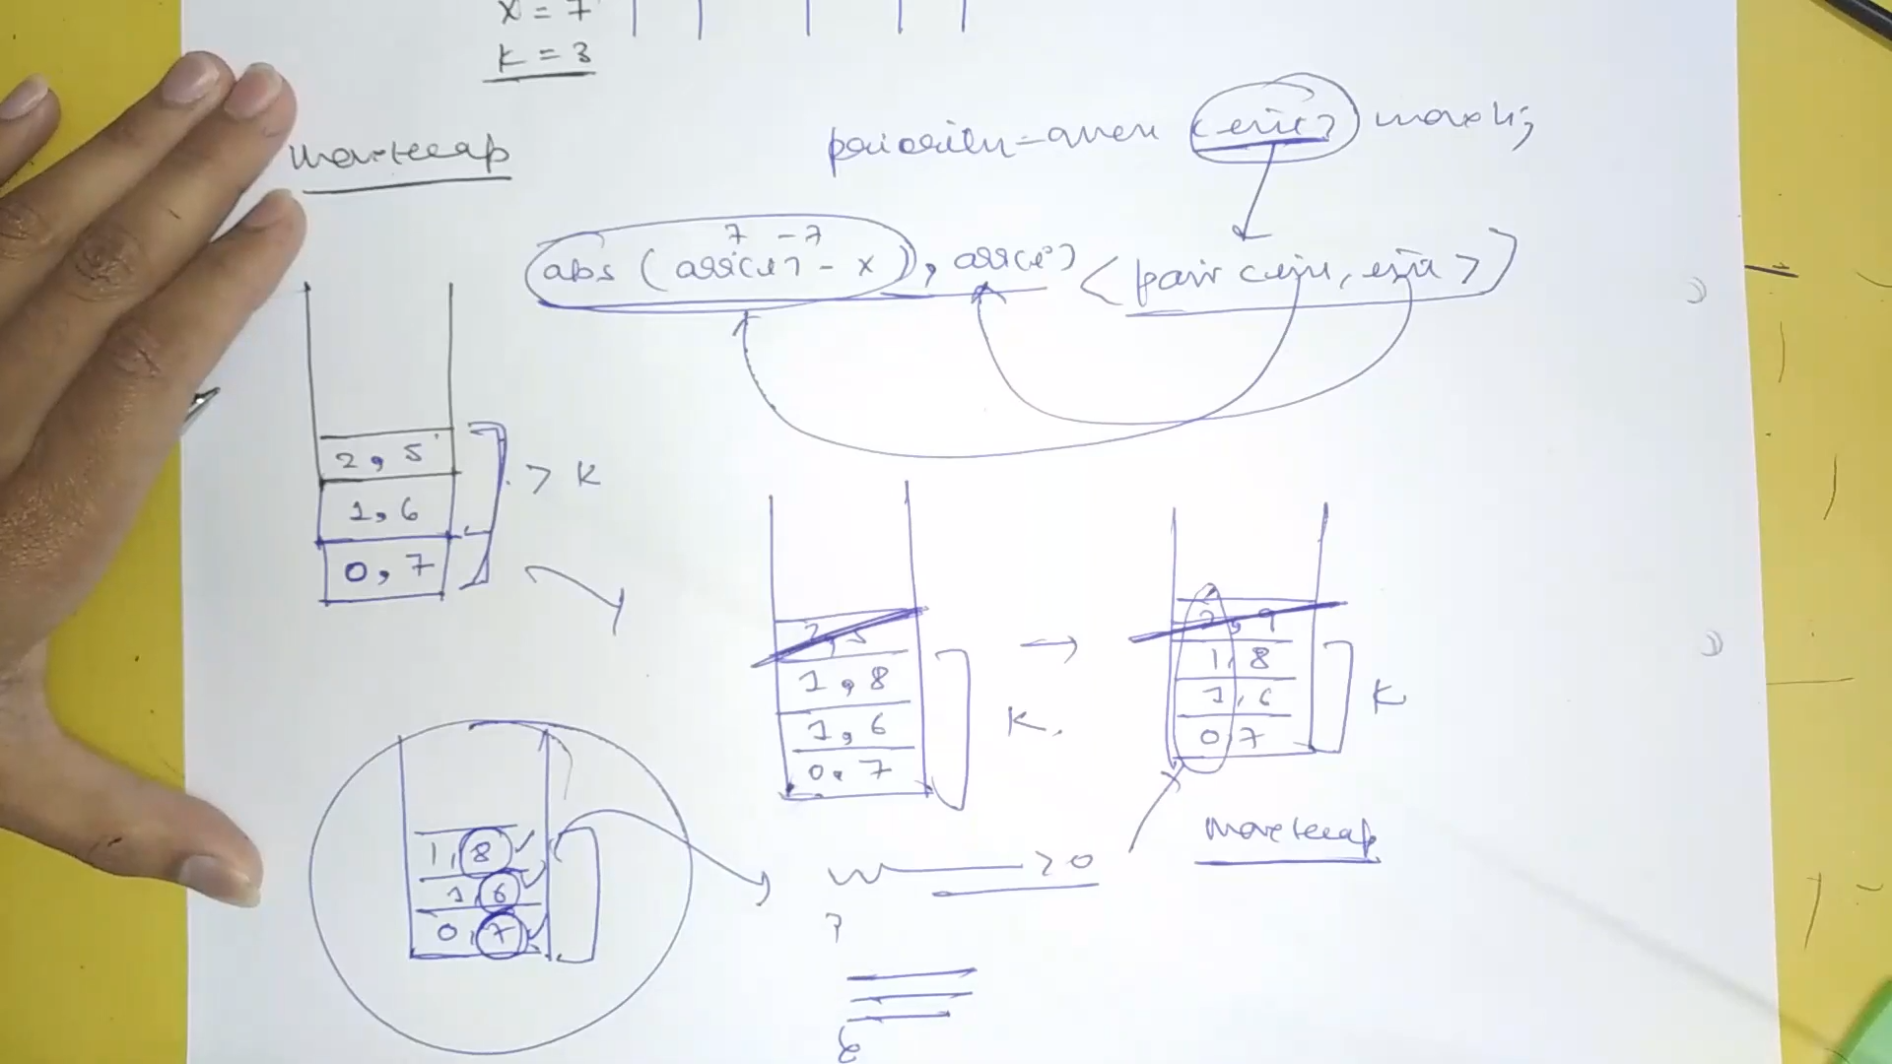

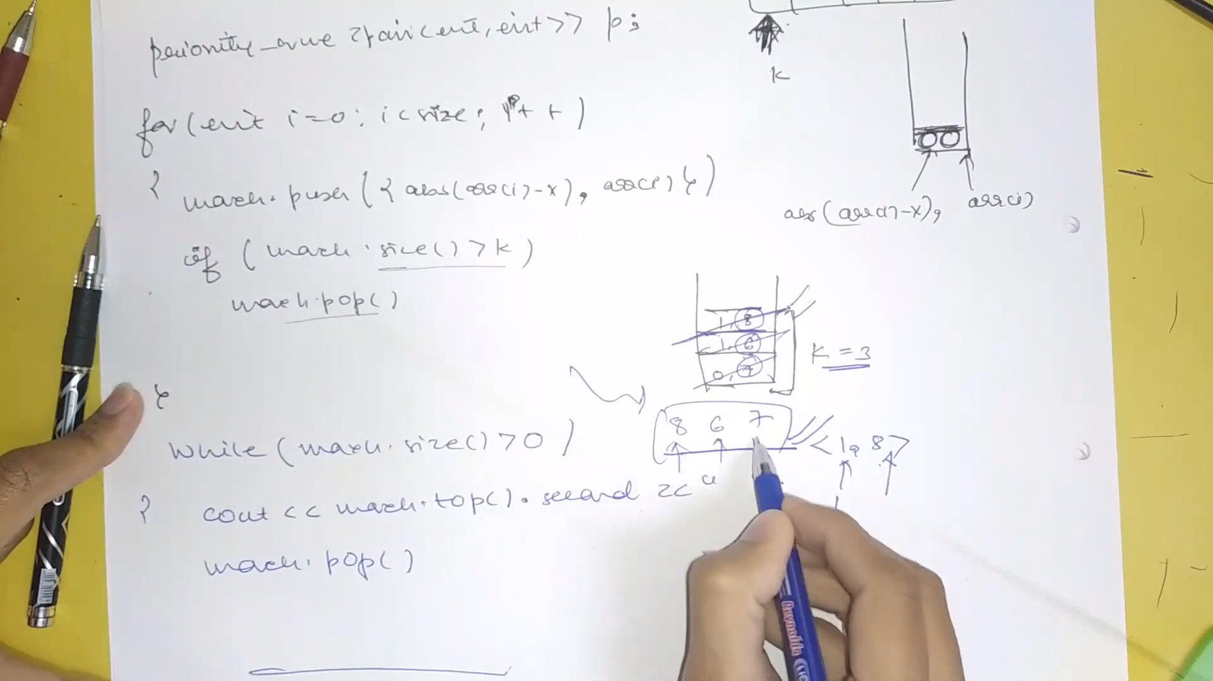

Order can be anything just print elements.

**Problem 6: Video 6:** Top K Frequent Numbers

Transform the array to map with frequency.

Key of the heap is frequency.

Make a min heap and remove k above elements.

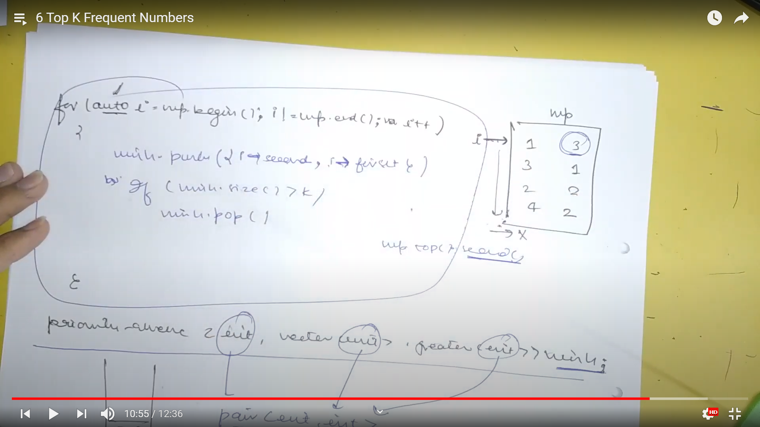

**Problem 7: Video 7:** Frequency Sort

Write number in the order of greater to least frequency.

Just make the map and push it completely in the max heap and then pop it.

Take frequency as the key.

class Solution {

public:

vector<int> topKFrequent(vector<int>& nums, int k) {

map<int,int> mappy;

priority_queue<pair<int, int> , vector<pair<int, int>>, greater<pair<int, int>>> pq;

for(int i = 0; i<nums.size(); i++)

mappy[nums[i]]++;

for(auto i = mappy.begin(); i!= mappy.end(); i++) {

pq.push({i->second,i->first});

if(pq.size()>k)

pq.pop();

}

vector<int> ans;

while(!pq.empty()) {

int p = pq.top().second;

ans.push_back(p);

pq.pop();

}

return ans;

}

};

**Problem 8: Video 8:** Closest Points to Origin

We are given a 2-D matrix and we have to find the k closest points.

Basically we need to minimize root of x^2 and y^2. So take key as root of x^2 and y^2 and generate a max heap and remove all elements above k unit in the heap.

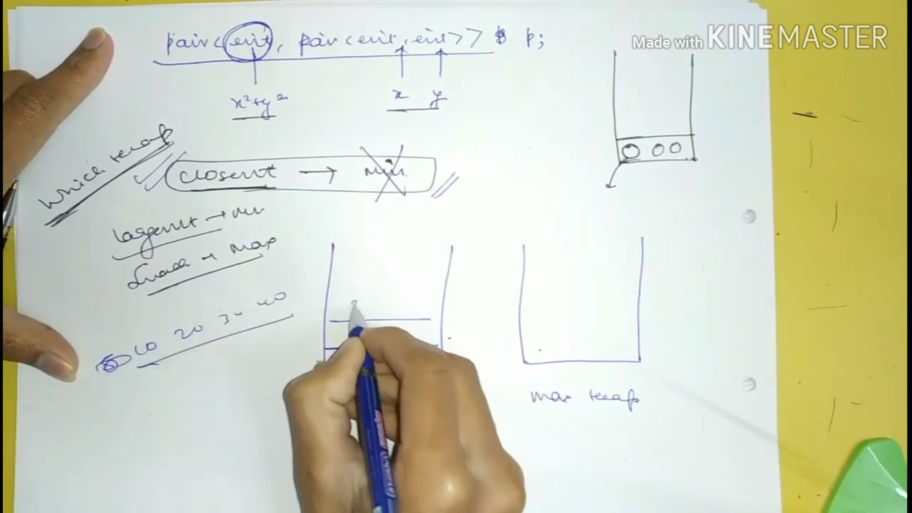

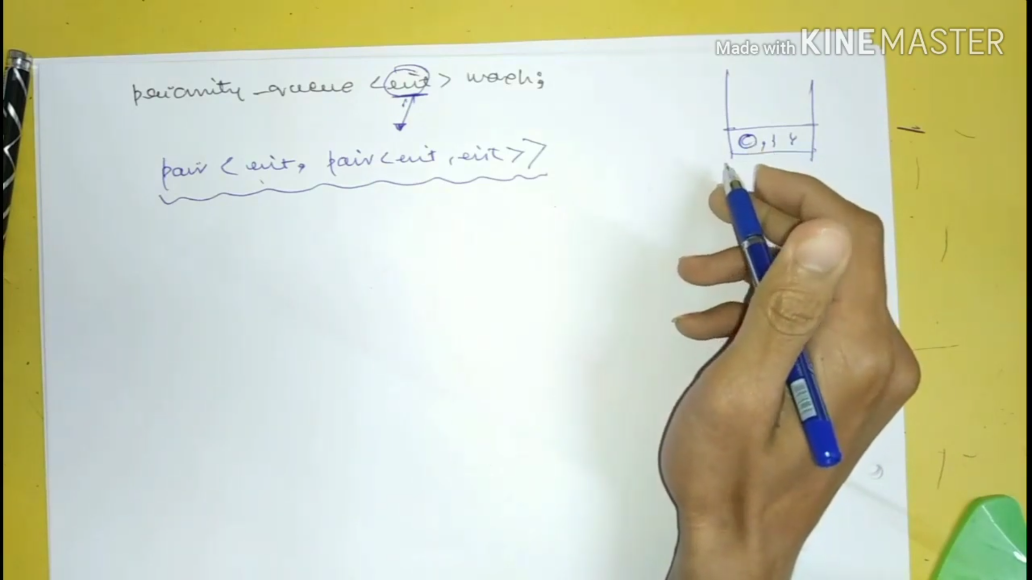

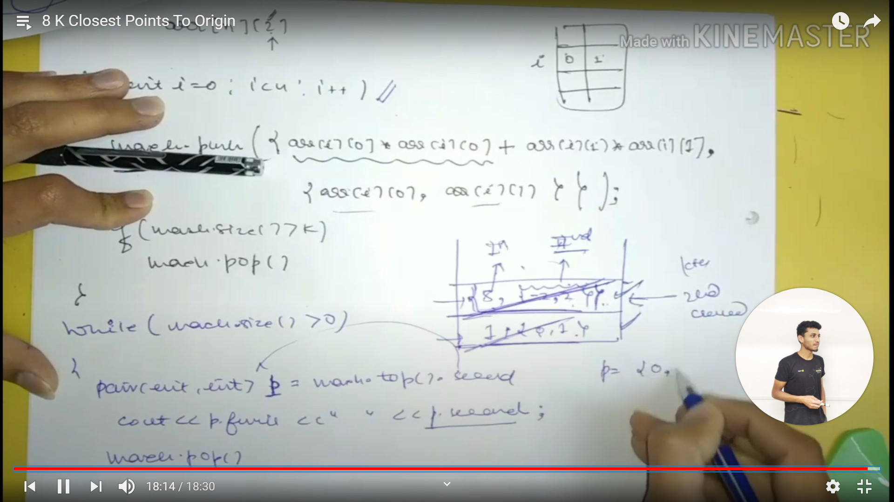

**Problem 9: Video 9:** Connect Ropes to Minimize the Cost

The rope we add keeps adding together and adds again to the total cost.

So we need to add them in such a way so that the total cost is less.

Make a min heap and keep popping the element and add it to the next popped element.

Now push this added result to the heap so that we can pop it and add it to the next popped element.

The total cost is the sum of each 2 elements added.

At last heap stores cost.

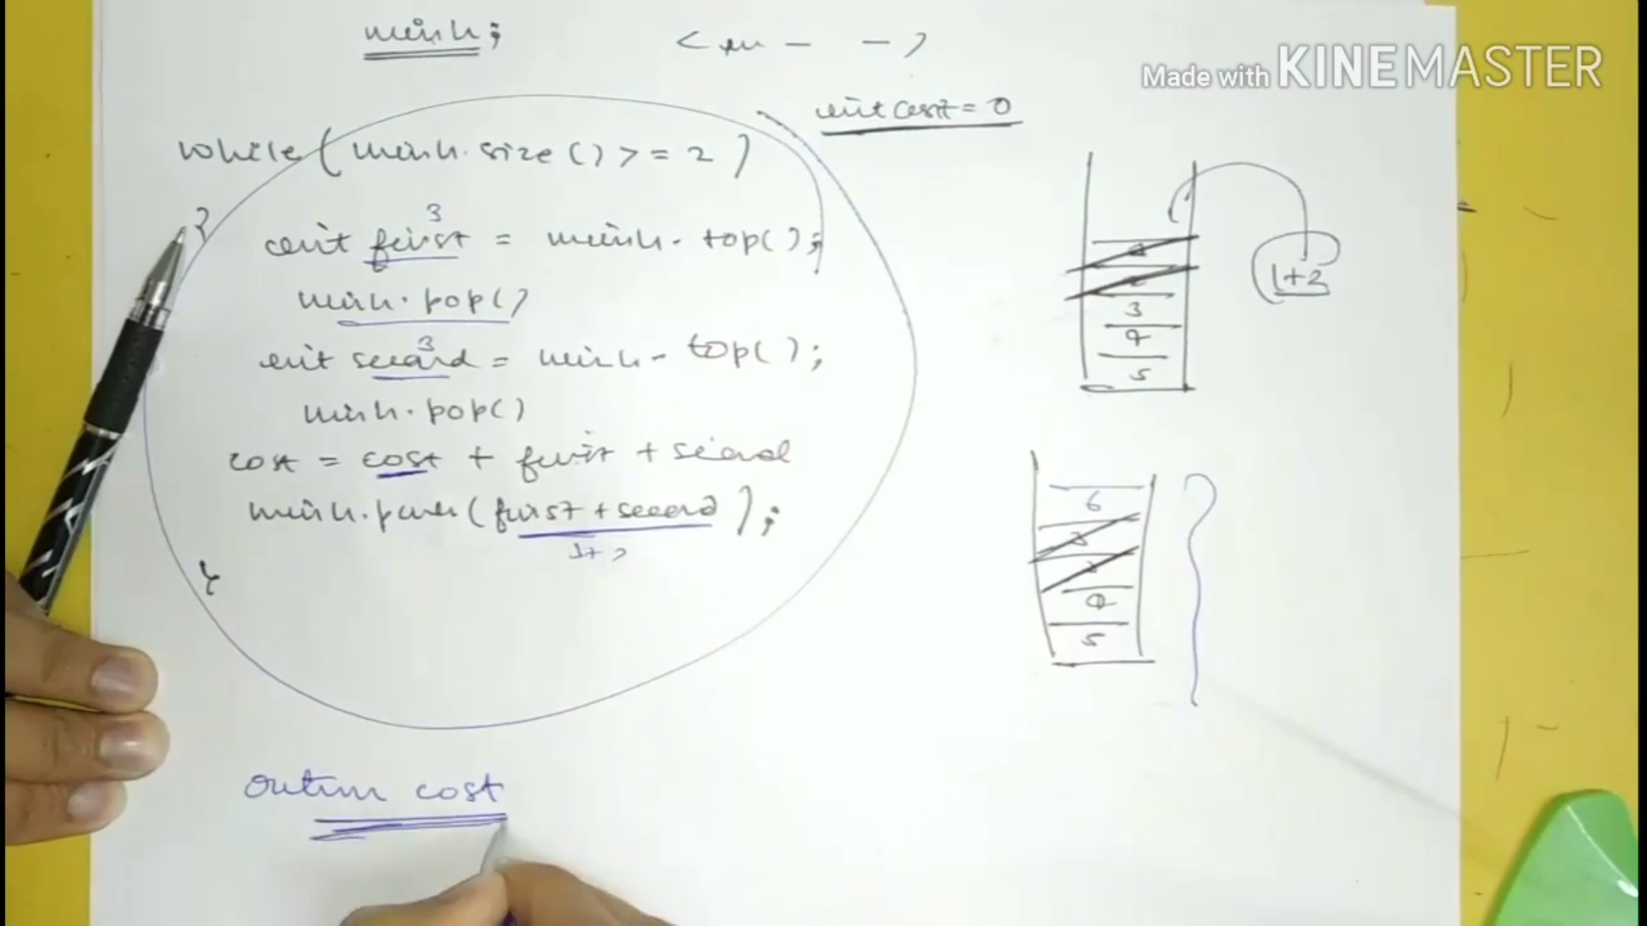

**Problem 10: Video 10:** Sum of elements between k1 smallest and k2 smallest numbers